FUNCTION POINTS

ER scheme

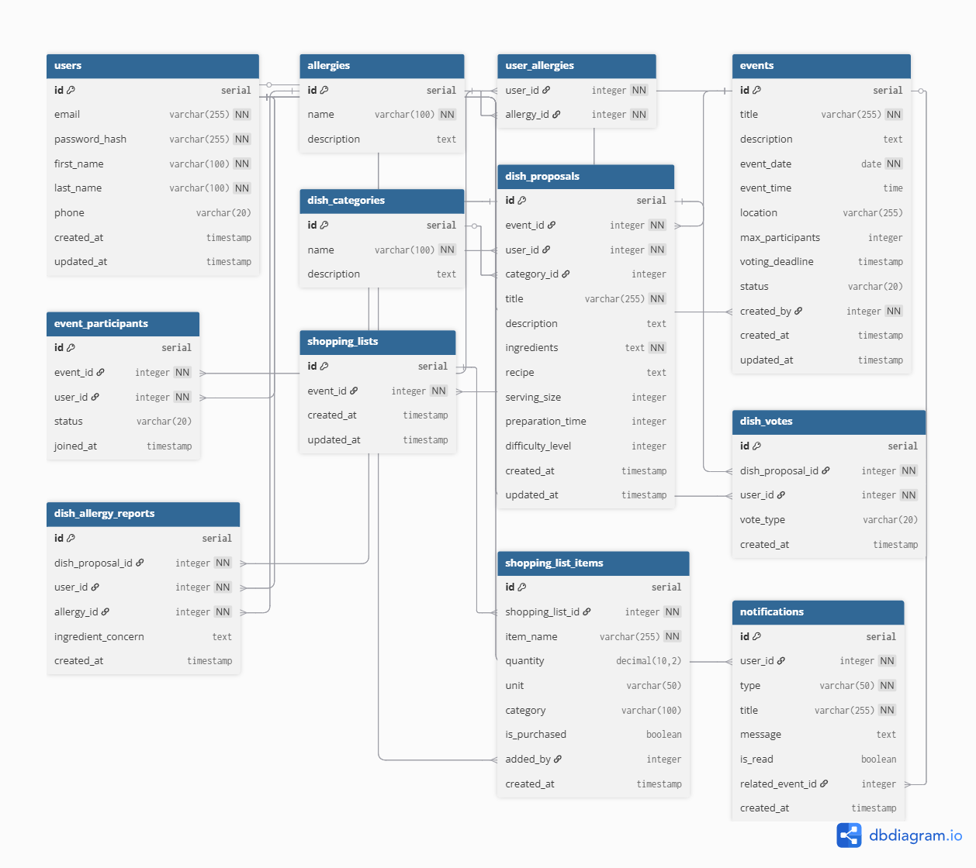

# ILF/EIF complexity:

| **Table** | **RET** | **DET** | **Complexity** | **FP** |
| --- | --- | --- | --- | --- |
| users | 1 | 7 | Low | 7 |
| events | 1 | 10 | Low | 7 |
| event_participants | 1 | 5 | Low | 7 |
| dish_categories | 1 | 3 | Low | 7 |
| dish_proposals | 1 | 11 | Low | 7 |
| dish_votes | 1 | 5 | Low | 7 |
| user_allergies | 1 | 2 | Low | 7 |
| dish_allergy_reports | 1 | 6 | Low | 7 |
| shopping_lists | 1 | 3 | Low | 7 |
| shopping_list_items | 1 | 8 | Low | 7 |
| notifications | 1 | 7 | Low | 7 |

Total ILF Function Points: 77

# EI (External Inputs)

| **Operation** | **FTR** | **DET** | **Complexity** | **FP** |
| --- | --- | --- | --- | --- |
| INSERT Event | 2 | 6 | Medium | 4 |
| UPDATE EventParticipants | 1 | 2 | Low | 3 |
| INSERT DishCategory | 1 | 2 | Low | 3 |
| UPDATE DishCategory | 1 | 2 | Low | 3 |
| UPDATE Event | 1 | 3 | Low | 3 |
| INSERT User | 1 | 6 | Low | 3 |
| INSERT EventParticipant | 1 | 2 | Low | 3 |
| INSERT DishProposal | 1 | 5 | Low | 3 |
| INSERT DishVote | 1 | 2 | Low | 3 |
| INSERT UserAllergy | 1 | 2 | Low | 3 |
| INSERT ShoppingListItem | 1 | 3 | Low | 3 |
| DELETE ShoppingListItem | 1 | 1 | Low | 3 |
| UPDATE ShoppingListItem | 1 | 1 | Low | 3 |
| DELETE EventParticipant | 1 | 1 | Low | 3 |

Total EI Function Points: 43

# EO (External Outputs)

| **Operation** | **FTR** | **DET** | **Complexity** | **FP** |
| --- | --- | --- | --- | --- |
| INSERT FinalMenu | 2 | 3 | Low | 4 |
| INSERT ShoppingList | 2 | 3 | Low | 4 |
| INSERT Notification | 2 | 3 | Low | 4 |
| SELECT DishProposal (tie) | 2 | 2 | Low | 4 |

Total EO Function Points: 16

# EQ (External Queries)

| **Operazione** | **FTR** | **DET** | **Complexity** | **FP** |
| --- | --- | --- | --- | --- |
| SELECT Events | 1 | 3 | Low | 3 |
| SELECT User Info | 1 | 4 | Low | 3 |
| SELECT Participants | 1 | 2 | Low | 3 |
| SELECT DishVotes | 1 | 3 | Low | 3 |

Total EQ Function Points: 12

→ **TOTAL FUNCTION POINTS** = 77 + 43 + 16 + 12 = 148